2. (4pts) How do you make the following solutions? (You should include both solute and solvent.)
a. 0.2L of 100mM CaCl₂. ___________________________________________________________
b. 50mL of 2% Dry Powdered Milk. ___________________________________________________
c. 500mL of 15mM NaCl. ___________________________________________________________
d. 5mL of 1x solution from a 10x stock. ________________________________________________

3. (2pts) You are given NaCl (dry powder), a bottle of 100% methanol (liquid), and distilled water. You need to make 200mL of a solution that is of 1% NaCl in 10% methanol. Explain how you would make this solution. ___________________________________________________________
________________________________________________________________________________

4. (3pts) The three main steps of Cell Communication are (in the correct order):
1. __________________ 2. __________________ 3. __________________

5. (6pts) Fill in the blanks on the table below for different types of cell communication
Type of Communication | Name of Ligand | How ligand travels to Target
1.
2.
3.

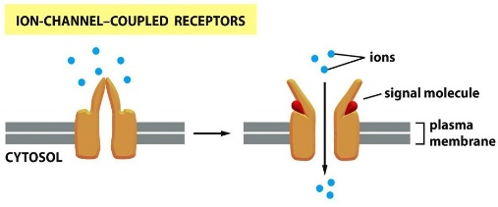
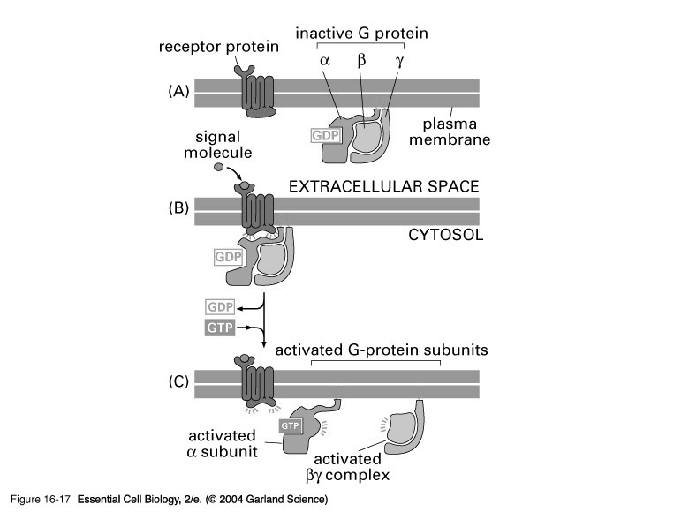
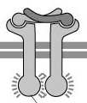
6. (4pts) Label these receptor types with their names.

____________ ____________ ____________ ____________

7. (2pts) Describe the signaling pathway of Testosterone (a hydrophobic hormone)
Step 1: ____________________________________________________________________
Step 2: ____________________________________________________________________
Step 3: ____________________________________________________________________
Step 4: ____________________________________________________________________
8a. (1pt) Would you expect the testosterone response to be FAST or SLOW? __________________
Explain: _________________________________________________________________________
8b. (1pt) Does Testosterone cause the same response in EVERY cell type? ___________________
Explain: ________________________________________________________________________

9. (4pts) Fill in the following table on the Specific Receptor Types.
Intracellular receptor OR Cell Surface receptor?
Enzyme Linked Receptor
G.P.C.R.
Ion Channel Linked Receptor
Hydrophobic hormone receptor

10. (4pts) Fill in the following table on describing two types of Receptors.
Intracellular receptor OR Cell Surface receptor?
Ligand does not enter cytosol of cell?
Ligand is larger hydrophilic molecule?
Receptor is an activator of TXN?
Receptor is a transmembrane protein?

11. (4pts) Put the following steps of a GPCR transduction pathway in order from 1 to 8.
__ cAMP is made in large amounts by breaking apart ATP.
__ G-protein alpha subunit activates Adenylyl Cyclase.
__ G-protein lets go of GDP, and binds to GTP.
__ PKA’s enzymatic activity is turned on.
__ Ligand binds to Receptor, activating the receptor
__ PKA phosphorylates CREB.
__ Gene expression is changed.
__ CREB binds to promoters on specific genes to activate TXN.

12. Answer the following questions about GPCRs.
(1pt) What do the letters “G.P.C.R.” mean? _____________________________________________ (1pt) Is there only one type of GPCR or is there a protein family of GPCRs? __________________
(3pts) List at least three types of domains of a GPCR.
a. __________________ b. __________________ c. __________________

13. Answer the following questions about trimeric G-proteins.
(1pt) Why are trimeric G-proteins called “trimeric”? _____________________________________
(1pt) Why are they called “G-Proteins”? _______________________________________________
(1pt) What attaches trimeric G-proteins to the plasma membrane? __________________________
(1pt) Which subunit of the G-protein is an enzyme? ______________________________________
(1pt) What is the substrate of the G-protein enzyme? ____________________________________
(1pt) What are the products of the G-protein enzyme? ___________________________________

(2pts) Describe how a trimeric G-protein (linked to a receptor) is activated (turns ON). __________
________________________________________________________________________________
________________________________________________________________________________
(2pts) Describe how a trimeric G-protein (linked to a receptor) is inactivated (turns OFF). _______
________________________________________________________________________________
________________________________________________________________________________

14. Answer the following questions about cAMP.
(1pt) What do the letters “c.A.M.P.” mean? ____________________________________________
(1pt) cAMP is called a “_____________________________ messenger” in Transduction Pathways.
(1pt) What enzyme makes cAMP? ___________________________________________________
(1pt) What molecule is used as that enzyme’s substrate to make cAMP? _____________________
(1pt) Does the production of cAMP represent Amplification OR Divergence within the Signal Transduction pathway? ____________________________________________________________
(1pt) What enzyme is activated by cAMP? _____________________________________________

15. (4pts) Explain step-by-step the transduction pathway of Acetylcholine in the heart.

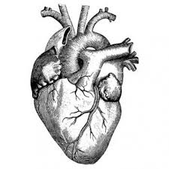
Step 1: ____________________________________________________________________
Step 2: ____________________________________________________________________
Step 3: ____________________________________________________________________
Step 4: ____________________________________________________________________

16. (4pts) Explain step-by-step the transduction pathway of Epinephrine (Adrenalin) in the heart.

Step 1: ____________________________________________________________________
Step 2: ____________________________________________________________________
Step 3: ____________________________________________________________________
Step 4: ____________________________________________________________________
Step 5: ____________________________________________________________________
Step 6: ____________________________________________________________________

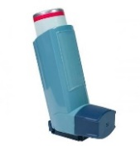
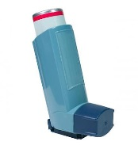
17. People with asthma who have trouble breathing often take an “inhaler” of a drug called Albuterol. Albuterol has been shown to bind to the same receptor as Epinephrine. Albuterol opens the airways and allows people to get more air into their lungs.

17a. (1pt) Is albuterol an AGONIST or an ANTAGONIST for the Epinephrine receptor? ________

FOR THE NEXT QUESTION- I WILL NOT GIVE CREDIT IF YOUR ANSWER SOUNDS LIKE IT WAS COPIED FROM A WEBSITE. USE YOUR OWN WORDS.

17b. (2pts) A side effect of Albuterol is an increase in heart rate. Logically explain WHY Albuterol increases heart rate using your answer to question #13. ________________________________________________________________________________
________________________________________________________________________________


18. Propranolol is an antagonist of receptors on the heart. Many actors, singers, and musicians will use this drug to slow their heart rate during a performance so that they don’t feel as nervous.

18a. (1pt) Propanolol is an antagonist drug. Is it an antagonist for the acetylcholine receptor OR an antagonist for the epinephrine receptor? _______________________________________________

FOR THE NEXT QUESTION- I WILL NOT GIVE CREDIT IF YOUR ANSWER SOUNDS LIKE IT WAS COPIED FROM A WEBSITE. USE YOUR OWN WORDS.
18b. (2pts) Using this information and the transduction pathway from the earlier question, explain how propanolol works. ________________________________________________________________________________
________________________________________________________________________________
________________________________________________________________________________
FUN FACT!!! Dr. James W. Black, was awarded the Nobel Prize in Medicine in 1988 for the discovery of propranolol!!!

19. Caffeine is a drug found in coffee, tea, and redbull.
Caffeine inhibits the enzyme (PDE) that breaks cAMP into AMP.

Caffeine
PDE enzyme
cAMP AMP

FOR THE NEXT QUESTION- I WILL NOT GIVE CREDIT IF YOUR ANSWER SOUNDS LIKE IT WAS COPIED FROM A WEBSITE. USE YOUR OWN WORDS.
(2pts) Knowing the transduction pathway for Epinephrine, explain step-by-step how caffeine increases heart rate. Be logical in your explanation.
Step 1: ____________________________________________________________________
Step 2: ____________________________________________________________________
Step 3: ____________________________________________________________________
Step 4: ____________________________________________________________________
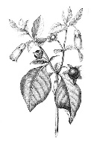
20. Atropine is a compound that comes from the “Deadly Nightshade” plant. Atropine binds to the acetylcholine receptor and is often used in hospitals when a patient’s heart is beating too slowly (“bradycardia”) or has stopped.

20a. (1pt) Is atropine an AGONIST or an ANTAGONIST for the Acetylcholine receptor? ________

FOR THE NEXT QUESTION- I WILL NOT GIVE CREDIT IF YOUR ANSWER SOUNDS LIKE IT WAS COPIED FROM A WEBSITE. USE YOUR OWN WORDS.
20b. (2pts) Using this information and the transduction pathway, explain how atropine works. ________________________________________________________________________________
________________________________________________________________________________
________________________________________________________________________________
FUN FACT!!! “Deadly Nightshade” (the Atropine plant) is also called “Belladonna” or “Beautiful Lady”. Women (including Queen Cleopatra) would take Belladonna to dilate the pupils of their eyes to look more beautiful.

21a. (2pts) What does the word endogenous mean? (Use your own words.) ____________________
________________________________________________________________________________
21b. (4pts) Drugs, medicines, and poisons often work by acting on endogenous proteins. They do this by looking similar to a signal molecule and binding to the endogenous protein. Look up these four examples to fill in this chart.
Drug, medicine, or poison | Looks similar to this endogenous molecule: | Binds to this endogenous protein/receptor:
Muscarine
Coniine
Prozac
Tamoxifen

22. Nicotine is a drug that binds to a receptor that is endogenous in our body.
22b. (1pt) What receptor does nicotine bind to? _________________________________________
22c. (1pt) Is nicotine an agonist or an antagonist for this receptor? ___________________________
22d. (2pts) Explain why nicotine changes heart rate (using the signaling pathway from the earlier question about the heart). ___________________________________________________________
________________________________________________________________________________
22e. (1pt) Why do tobacco plants make nicotine? (Is it because tobacco plants wants humans to smoke cigarettes and get lung cancer?) _________________________________________________

23a. (1pt) After glucose is fully catabolized in Cell Respiration, where (what molecule) are the carbon atoms that were originally in the glucose molecule? ________________________________
23b. (1pt) After glucose is fully oxidized in Cell Respiration, where (what molecule) are the electrons that were originally on the glucose molecule? ___________________________________

24a. (4pts) What happens to the electron transport system if the cell is not given any food?
(Please answer in a logical way that explains step-by-step what would happen.)
YOUR ANSWER SHOULD LINK FOOD TO THE ELECTRON TRANSPORT SYSTEM.
________________________________________________________________________________
________________________________________________________________________________
24b. (4pts) What happens to the electron transport system if the cell is not given any O₂ gas? (Please answer in a logical way that explains step-by-step what would happen.)
YOUR ANSWER SHOULD LINK O₂ GAS TO THE ELECTRON TRANSPORT SYSTEM.
________________________________________________________________________________
________________________________________________________________________________

